**Julia Scott**

Fashion Designer



**SUMMARY**

A passionate and skilled fashion designer with a focus on sustainable practices and trend forecasting. Equipped with extensive experience in garment construction and digital fashion tools. Committed to delivering innovative, eco-friendly designs. Strong team collaborator, adept at balancing creativity with technical execution.

ss



**EDUCATION**

2018 **BA (Hons) Fashion Design**

*University of West England, Bristol*

2016 **Diploma in Textile Design**

*London College of Fashion*



**EXPERIENCE**

2021 – Now **Junior Fashion Designer**

*Studio Luxe, Bristol, UK*

Designed women’s wear collections, created technical sketches, and oversaw sample production. Researched trends and sourced sustainable fabrics.

2018 – 2021 **Assistant Fashion Designer**

*Bella Couture, Bristol, UK*

Assisted with sketching, fabric sourcing, design fittings, mood boards, and client presentations, ensuring brand alignment.

2017 – 2018 **Fashion Designer Intern**

*Harper & Co., London, UK*



**HOBBIES**

* Fashion Illustrations
* Fashion Events
* Travel Inspiration
* Photography
* Textile Art

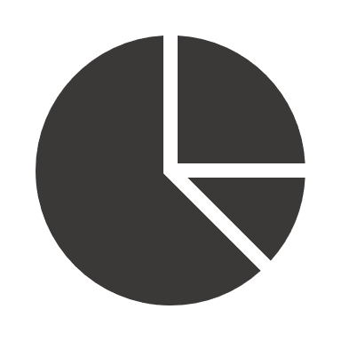

**SKILLS**

* Fashion Illustration
* Garment Construction
* Digital Design (Adobe Illustrator, Photoshop)
* Trend Research
* Sustainable Practices
* Fabric Sourcing



**CONTACT**

**Location**

Bristol, United Kingdom

**Phone**

+44 20 7946 5678

**Email**

julia.scott@email.com

**LinkedIn**

linkedin.com/in/juliascott